Assignment 2

1. a. **Explain** in detail with **a neat diagram** Michael Porter’s classic model of competition (five force model)

**PORTER’S COMPETITIVE FORCES MODEL (1)**

Arguably, the most widely used model for understanding competitive advantage is Michael Porter’s **competitive forces model** (see Figure 3.8). This model provides a general view of the firm, its competitors, and the firm’s environment. Earlier in this chapter, we described the importance of a firm’s environment and the dependence of firms on environments. Porter’s model is all about the firm’s general business environment. In this model, five competitive forces shape the fate of the firm.

**PORTER’S COMPETITIVE FORCES MODEL** 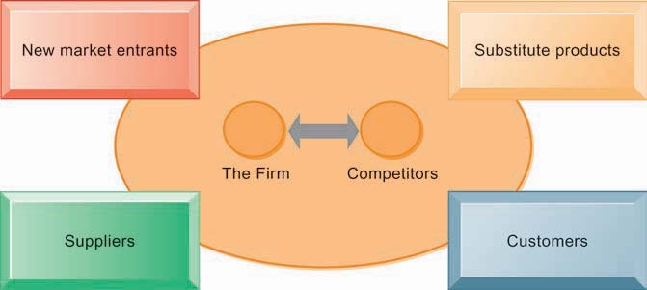

In Porter’s competitive forces model, the strategic position of the firm and its strategies are determined not only by competition with its traditional direct competitors but also by four other forces in the industry’s environment: new market entrants, substitute products, customers, and suppliers.

page125image44179584

**Traditional Competitors**

All firms share market space with other competitors who are continuously devising new, more efficient ways to produce by introducing new products and services, and attempting to attract customers by developing their brands and imposing switching costs on their customers.

**New Market Entrants**

In a free economy with mobile labor and financial resources, new compa- nies are always entering the marketplace. In some industries, there are very low barriers to entry, whereas in other industries, entry is very difficult. For instance, it is fairly easy to start a pizza business or just about any small retail business, but it is much more expensive and difficult to enter the computer chip business, which has very high capital costs and requires significant exper- tise and knowledge that is hard to obtain. New companies have several possible advantages: They are not locked into old plants and equipment, they often hire younger workers who are less expensive and perhaps more innovative, they are not encumbered by old worn-out brand names, and they are “more hungry” (more highly motivated) than traditional occupants of an industry. These advantages are also their weakness: They depend on outside financing for new plants and equipment, which can be expensive; they have a less-experienced workforce; and they have little brand recognition.

**Substitute Products and Services**

In just about every industry, there are substitutes that your customers might use if your prices become too high. New technologies create new substitutes all the time. Even oil has substitutes: Ethanol can substitute for gasoline in cars; vegetable oil for diesel fuel in trucks; and wind, solar, coal, and hydro power for industrial electricity generation. Likewise, the Internet telephone service can substitute for traditional telephone service, and fiber-optic telephone lines to the home can substitute for cable TV lines. And, of course, an Internet music service that allows you to download music tracks to an iPod is a substitute for CD-based music stores. The more substitute products and services in your industry, the less you can control pricing and the lower your profit margins.

**Customers**

A profitable company depends in large measure on its ability to attract and retain customers (while denying them to competitors), and charge high prices. The power of customers grows if they can easily switch to a competitor’s prod- ucts and services, or if they can force a business and its competitors to compete on price alone in a transparent marketplace where there is little **product dif- ferentiation**, and all prices are known instantly (such as on the Internet). For instance, in the used college textbook market on the Internet, students (cus- tomers) can find multiple suppliers of just about any current college textbook. In this case, online customers have extraordinary power over used-book firms.

**Suppliers**

The market power of suppliers can have a significant impact on firm profits, especially when the firm cannot raise prices as fast as can suppliers. The more different suppliers a firm has, the greater control it can exercise over suppliers in terms of price, quality, and delivery schedules. For instance, manufacturers of laptop PCs almost always have multiple competing suppliers of key compo- nents, such as keyboards, hard drives, and display screens.

1. **Explain** in detail with a **neat diagram** The Value Chain and Strategic IS (Answer in 1 to 2 pages)   
   What Is a Value Chain? (2)

A value chain is a model that includes every step a company goes through — from the initial idea through delivery to the customer — to create a good or service. The value chain includes initial design, materials sourcing, manufacturing, marketing, sale, delivery and after-sale service. If that sounds a lot like a supply chain, it should. Value chains encompass more business activities than supply chains, but the main difference is their customer-focused point of view.

By studying the value chain, businesses can go step by step to find places to add values that customers look for when choosing where to spend their money. Not every business has the time or resources to perform a full analysis of its value chain — that would require a deep look at every step of production for every product — but many companies benefit from some value chain analysis on their highest-cost products, specific departments or anywhere they feel that a deeper look is needed before implementing efficiency improvements.

The goal of the value chain model is to help a business gain an advantage over its competitors by increasing the value its products offer to customers. Once decision-makers or managers map out the steps in the value chain — either for one product or as a broad look at a company’s processes — they can analyze the costs and rewards of each step. That analysis then informs decisions about decreasing costs or increasing the value of a product in the eye of the customer. Lower costs can lead to higher profit margins or lower prices for the good, creating a “cost advantage” over competitors. And when customers view a product as more valuable than a comparable good, they are often willing to purchase it more often or pay higher prices, giving the business a “differentiation advantage”.

For example, let’s say a company’s value chain analysis highlights that its use of high-quality raw materials is driving up the cost of manufacturing. If the company’s goal is to gain a cost advantage over competitors, it can consider cost-cutting measures like changing suppliers or outsourcing costly parts of the process. If the business is aiming for a differentiation advantage, it can emphasize its high-quality materials and manufacturing processes in its marketing, positioning the product as a premium item — and charging a premium price. Both approaches to competitive advantage are possible when a business understands its value chain, and both have the same ultimate financial goal — higher profits.

page133image111374112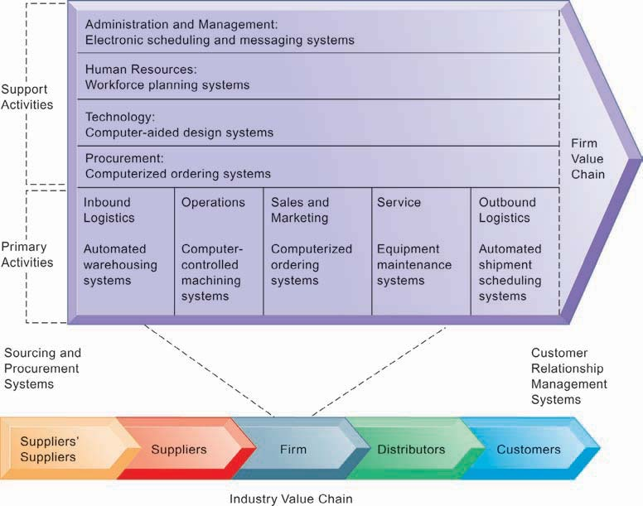

This figure provides examples of systems for both primary and support activities of a firm and of its value partners that can add a margin of value to a firm’s products or services.

b. 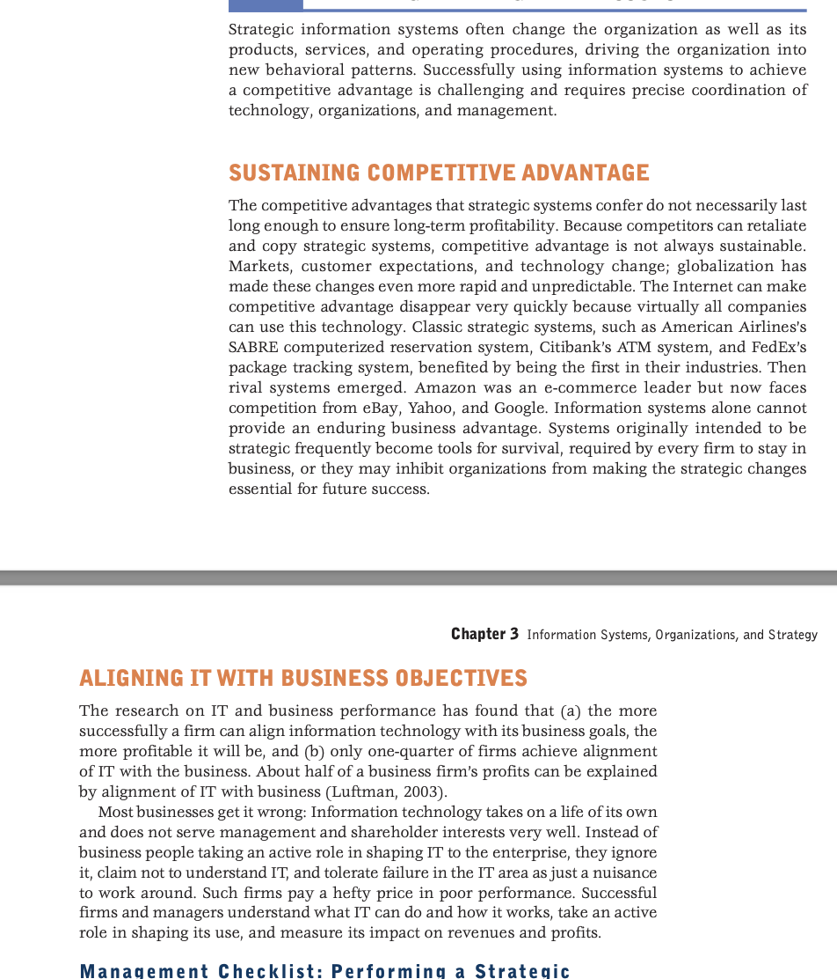  
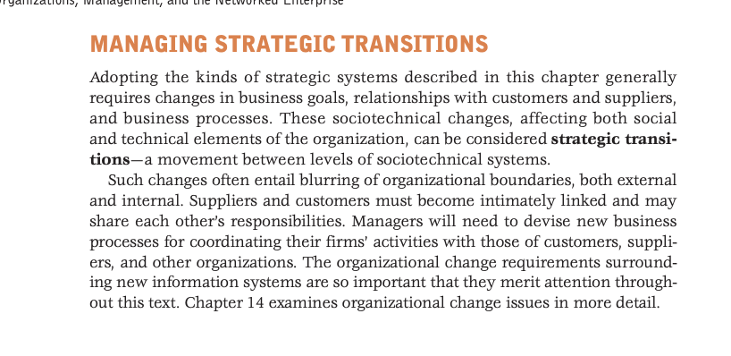

1. a. What is **CRM,** draw a **table** showing CRM software capabilities. Explain **Operational** and **Analytical** CRM.

*Managing the full range of the customer relationship involves two related objectives: one, to provide the organization and all of its customer-facing employees with a single, complete view of every customer at every touchpoint and across all channels; and, two, to provide the customer with a single, complete view of the company and its extended channels.*

That’s why companies are turning to **customer relationship management** to improve their customer focus. CRM uses information technology to create a cross-functional enterprise system that integrates and automates many of the *customer-serving* processes in sales, marketing, and customer services that interact with a company’s customers. CRM systems also create an IT framework of Web-enabled software and databases that integrates these processes with the rest of a company’s business operations. CRM sys- tems include a family of software modules that provides the tools that enable a business and its employees to deliver fast, convenient, dependable, and consistent service to its customers. Siebel Systems, Oracle, PeopleSoft, SAP AG, and Epiphany are some of the leading vendors of CRM software. Figure 8.3 illustrates some of the major application components of a CRM system. Let’s take a look at each of them.

CRM software helps sales, marketing, and service professionals capture and track rel- evant data about every past and planned contact with prospects and customers, as well as other business and life cycle events of customers. Information is captured from all customer touchpoints, such as telephone, fax, e-mail, the company’s Web site, retail stores, kiosks, and personal contact. CRM systems store the data in a common cus- tomer database that integrates all customer account information and makes it available throughout the company via Internet, intranet, or other network links for sales, mar- keting, service, and other CRM applications.

page386image44728320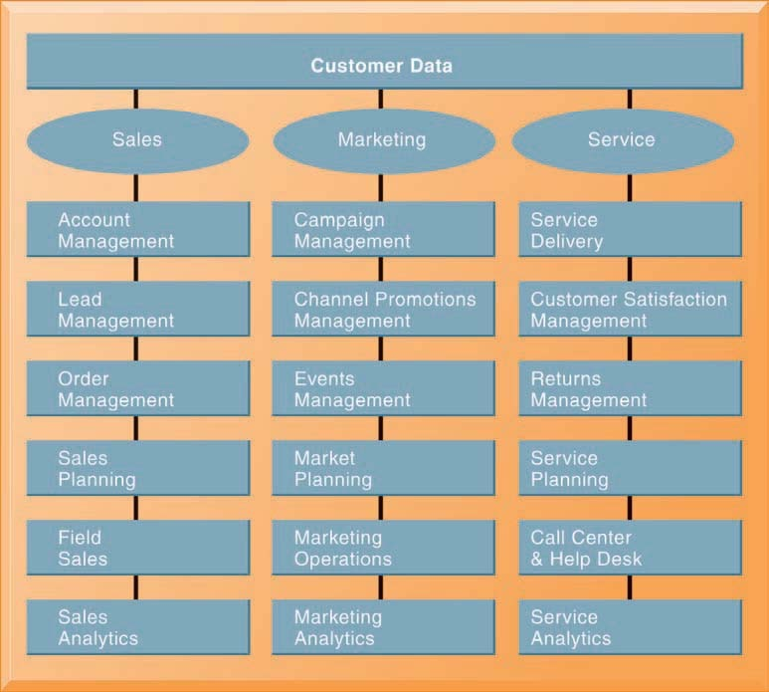

The major CRM software products support business processes in sales, service, and marketing, integrating customer information from many different sources. Included are support for both the operational and analytical aspects of CRM.

**Operational** and **Analytical** CRM.

All of the applications we have just described support either the operational or analytical aspects of customer relationship management.

**Operational CRM** includes customer-facing applications, such as tools for sales force automation, call center and customer service support, and marketing automation. Operational CRM comprises “the business processes and technol-ogies that can help improve the efficiency and accuracy of day-to-day customer-facing operations.” This includes sales, marketing,and service automation. Buttle defined Operational CRM as “aperspective on CRM which focuses on major automation projects with-in the front-office functions of selling, marketing and service.” Opera-tional CRM automates the business processes underpinning the day-to-day tasks of sales, marketing, and service functions across a range ofcustomer touch points and channels. Sales force automation appliestechnology to the management of selling activities to optimize salesproductivity by improving the speed and quality of information flowto improve internal communications between the sales force and man-agement. The general objective of Operational CRMis to improve the efficiency and effectiveness of customer manage-ment processes, by personalizing the relationship with customers, byimproving organizational response to customers’ needs and by increasing the speed and quality of information flows inthe organization, and between the organization and its external employ-ees and partners

**Analytical CRM** includes applications that analyze customer data generated by operational CRM applications to provide information for improving business performanceAnalytical CRM refers to the information management processes that rotate around the collection, accumulation, and analysisof customer information from customer interfaces. this information management process supports the strategy development process by providing information about market characteristics that can be used to develop customer strategy, as well as assist in the value creation pro-cess, determine customer lifetime value and develop new products andservices.Analytical CRM uses technology to accumulate, store, organize,interpret, distribute, and exploit customer data. Analytical CRM systems can increase revenue in many ways, such asthrough cross-sell and up-sell campaigns, predicting which customersare most likely to buy, identifying high value customers, increasingbrand awareness, and promoting customer satisfaction, loyalty and re-ferrals. Key success factors for Analytical CRM system implementation have been identified as the empowerment of manage-ment through the sharing of customer information and strong teamwork between marketing and customer service. The lack of an integrated view of customers, insufficient cus-tomer intelligence, inability to act on customer intelligence quickly, and the lack of the awareness of the potential benefit of Analytical CRM were identified as reasons forfailures to implement Analytical CRM systems effectively

(3)

b. **Enterprise Applications**: New **Opportunities** and **Challenges**

**ENTERPRISE APPLICATIONS: NEW OPPORTUNITIES AND CHALLENGES**

Many firms have implemented enterprise systems and systems for supply chain and customer relationship management because they are such powerful instru- ments for achieving operational excellence and enhancing decision making. But precisely because they are so powerful in changing the way the organization works, they are challenging to implement. Let’s briefly examine some of these challenges, as well as new ways of obtaining value from these systems.

**ENTERPRISE APPLICATION CHALLENGES**

Enterprise applications require not only deep-seated technological changes but also fundamental changes in the way the business operates. Companies must make sweeping changes to their business processes to work with the software. Employees must accept new job functions and responsibilities. They must learn how to perform a new set of work activities and understand how the information they enter into the system can affect other parts of the company. This requires new organizational learning.

Supply chain management systems require multiple organizations to share information and business processes. Each participant in the system may have to change some of its processes and the way it uses information to create a system that best serves the supply chain as a whole.

Enterprise applications also introduce “switching costs.” Once you adopt an enterprise application from a single vendor, such as SAP, Oracle, or others, it is very costly to switch vendors, and your firm becomes dependent on the vendor to upgrade its product and maintain your installation.

Enterprise applications are based on organization-wide definitions of data. You’ll need to understand exactly how your business uses its data and how the data would be organized in a customer relationship management, supply chain management, or enterprise system. CRM systems typically require some data cleansing work.

Enterprise software vendors are addressing these problems by offering pared-down versions of their software and “fast-start” programs for small and medium-sized businesses and best-practice guidelines for larger companies. The Interactive Session on Technology describes how on-demand and cloud-based tools deal with this problem as well.

**NEXT-GENERATION ENTERPRISE APPLICATIONS**

Today, enterprise application vendors are delivering more value by becom- ing more flexible, Web-enabled, and capable of integration with other systems. Stand-alone enterprise systems, customer relationship management systems, and supply chain management systems are becoming a thing of the past. The major enterprise software vendors have created what they call *enterprise solutions*, *enterprise suites*, or e-business suites to make their customer relation- ship management, supply chain management, and enterprise systems work closely with each other, and link to systems of customers and suppliers. SAP Business Suite, Oracle e-Business Suite, and Microsoft Dynamics suite (aimed at mid-sized companies) are examples, and they now utilize Web services and service-oriented architecture (SOA).

Next-generation enterprise applications also include open source and on-demand solutions, as well as more functionality available on mobile platforms. Open source products such as Compiere, Apache Open for Business (OFBiz), and Openbravo lack the functionality and support provided by commercial enterprise application software, but are attractive to companies such as small manufacturers because there are no software licensing charges and fees are based on usage. For small and medium-sized businesses in select countries, SAP now offers cloud-based versions of its Business One OnDemand and Business ByDesign enterprise software solutions. Software as a service (SaaS) and cloud-based versions of enterprise systems are starting to be offered by smaller vendors such as NetSuite and Plex Online. The Interactive Session on Technology describes some of the cloud-based systems for CRM. Over time, more companies will be choosing to run all or part of

**Resources:**

1. Kenneth C. Laudon, Jane P. Laudon Management Information System 13th
2. <https://www.netsuite.com/portal/resource/articles/erp/value-chain.shtml>
3. <https://www.researchgate.net/publication/200121232_Strategic_Operational_and_Analytical_Customer_Relationship_Management_Attributes_and_Measures>